|  |  |  |
| --- | --- | --- |
|  | **KONGU ENGINEERING COLLEGE**  (Autonomous)  Perundurai, Erode – 638 060  **DEPARTMENT OF ELECTRONICS AND COMMUNICATION ENGINEERING** | KEC | Kongu Engineering College |

**LIBRARY MANAGEMENT SYSTEM**

**for**

**23ITC31 – JAVA PROGRAMMING**

**Submitted by**

**POORIVKA - 23ECR153**

**SAHANA VARSHINI S S - 23ECR180**

**SAMPATHKUMAR S - 23ECR183**

|  |  |  |
| --- | --- | --- |
|  | **KONGU ENGINEERING COLLEGE**  (Autonomous)  Perundurai, Erode – 638 060  **DEPARTMENT OF ELECTRONICS AND COMMUNICATION ENGINEERING** | KEC | Kongu Engineering College |

**BONAFIDE CERTIFICATE**

Name & Roll No. : **POORVIKA (23ECR153)**

**SAHANA VARSHINI S S (23ECR180)**

**SAMPATHKUMAR S (23ECR183)**

Course Code : **22ITC31**

Course Name : **JAVA PROGRAMMING**

Semester : **III**

Certified that this is a bonafide record of work for application project done by the above students for **22ITC31– JAVA PROGRAMMING** during the academic year **2024-2025.**

Submitted for the Viva Voce Examination held on _____________________

**Faculty In-Charge Year In-charge**

**TABLE OF CONTENTS**

|  |  |  |
| --- | --- | --- |
| **CHAPTER No.** | **TITLE** | **PAGE No.** |
|  | **Abstract** | **1** |
| **1.** | **Introduction and Problem Statement** | **2** |
| **2.** | **Methodology** | **5** |
| **3.** | **Design and Implementation** | **9** |
| **4.** | **Results and Discussion** | **17** |
| **5.** | **Conclusion** | **19** |

**ABSTRACT**

* Libraries play a crucial role in the dissemination of knowledge, yet they face significant challenges in managing vast amounts of data manually. Common issues include difficulties in tracking book inventories, managing user records, and ensuring timely updates on book borrow and return statuses. These inefficiencies often lead to errors and delays, impacting the overall user experience and operational efficiency of libraries.
* To address these challenges, this project presents a Library Management System, designed and implemented using Java as the primary programming language and MySQL (via XAMPP) for database management. The system automates essential library operations, including book cataloging, user management, and transaction tracking (borrowing and returning). Features such as user authentication, real-time updates, and efficient data retrieval ensure seamless operation and accuracy. Additionally, the modular design allows for scalability and integration with online systems.
* The proposed solution demonstrates significant improvements over manual processes. It minimizes errors, enhances data accessibility, and streamlines operations, resulting in better service for users and reduced work load for library staff.
* This project highlights the potential of software solutions to revolutionize traditional library management.

**PROBLEM STATEMENT**

* Libraries serve as vital hubs for knowledge dissemination and resource sharing. However, managing the extensive operations involved in a library—such as book cataloging, user records, borrowing and returning of books—often becomes cumbersome, particularly when relying on manual processes. The traditional manual system of maintaining registers or spreadsheets for tracking books and user information is not only time-consuming but also prone to errors.

Some common challenges faced in manual library management include:

1. Data Errors: Frequent errors in recording book issuances, returns, and user details can lead to discrepancies in the inventory.
2. Resource Mismanagement: Books may be misplaced, over-issued, or not properly accounted for due to lack of real-time updates.
3. Time-Consuming Processes: Manual processes for issuing or returning books, checking availability, and managing fines are slow and inefficient.
4. Limited Accessibility: Records maintained in physical registers are not easily accessible or retrievable, leading to delays in service.
5. User Dissatisfaction: Slow services and errors often frustrate users, reducing the library’s overall efficiency and reputation.

* To address these issues, many libraries have started adopting digital systems. However, existing solutions often have their own limitations, such as high
* implementation costs, lack of user-friendliness, or inadequate features tailored to the needs of smaller libraries. Furthermore, some libraries lack the technical expertise to effectively utilize these systems, leading to underperformance.
* Given these challenges, the need for a more reliable, efficient, and user-friendly system becomes apparent. This project proposes a Library Management System that automates key operations, providing a streamlined and error-free environment for managing library functions.

The Library Management System will address the limitations of manual systems and existing software by offering:

1. Comprehensive Inventory Management: Real-time tracking of book availability, borrow and return records, and stock updates.
2. User Record Management: Maintenance of user profiles, borrowing history, and fines, ensuring quick retrieval of information.
3. Efficient Transaction Handling: Automated processes for book issuance, returns, and fine calculations.
4. Scalability and Accessibility: A system that can grow with the library’s needs and provide easy access to information for authorized personnel.
5. Error Minimization: Elimination of manual entry errors through automated data management.

* In conclusion, the proposed Library Management System will not only improve operational efficiency but also enhance the user experience by offering fast, accurate, and reliable services. This system represents a significant step forward in modernizing library management, ensuring it meets the demands of today’s digital age.
* Additionally, the proposed system will incorporate features such as search functionality to quickly locate books by title, author, or genre, and advanced reporting tools to generate insights into library usage, popular books, and overdue records. These features will empower librarians with the tools needed to make data-driven decisions, optimize inventory, and improve service quality.
* The system’s database design will ensure data integrity and security, preventing unauthorized access and safeguarding sensitive information about users and transactions. Furthermore, by integrating Java with MySQL, the system achieves a balance between robust functionality and ease of implementation, making it an ideal choice for libraries of varying sizes.
* The automated Library Management System will also reduce the reliance on manual labor, enabling library staff to focus on more strategic tasks such as community engagement and resource development. Its user-friendly interface ensures that even non-technical users can operate it with ease, minimizing the learning curve.
* By addressing the limitations of both manual processes and existing digital solutions, this system offers a comprehensive, cost-effective, and scalable solution to the challenges faced by libraries today. In a rapidly evolving digital world, such a system is crucial for libraries to remain relevant and continue serving as effective knowledge centers.
* The adaptability of the system ensures that it can evolve with the library’s needs, accommodating an expanding collection, increasing user base, and potential multi-branch operations. This versatility makes it a long-term solution for library management.
* By automating routine processes and introducing a structured, digital approach, this project contributes significantly to the modernization of traditional libraries. It enables them to transition into efficient, user-focused facilities while retaining their core mission of knowledge sharing and accessibility. This initiative aligns with the global movement towards digital transformation and highlights the importance of technology in improving public and institutional services.

**METHODOLOGY**

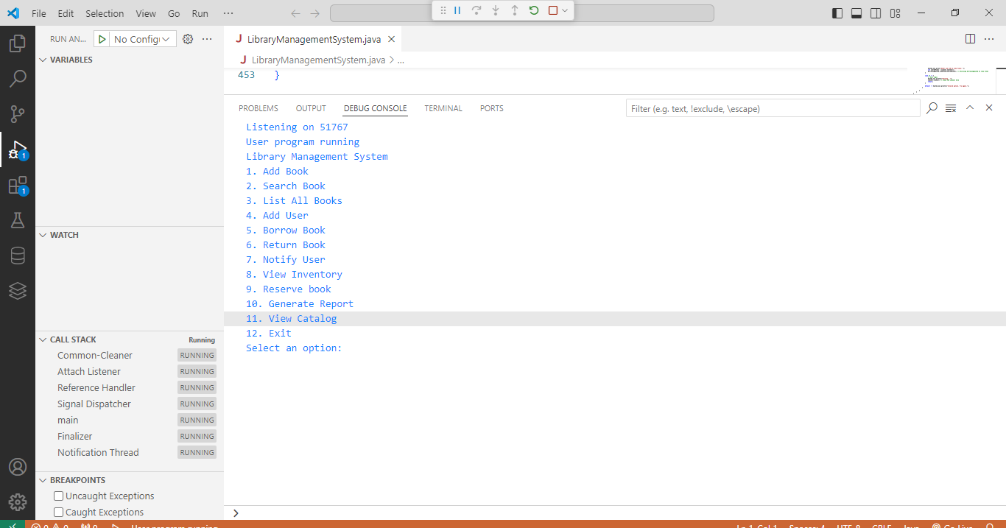

The development of the Library Management System follows a structured and systematic methodology to ensure it is functional, efficient, and scalable. Below is a detailed explanation of each step in the methodology:

1. **Requirement Analysis:**

This phase involves understanding the specific needs of the library.

* Conducted interviews with librarians and potential users to identify pain points in existing systems.
* Core functionalities identified include:
  + Book inventory management (add, update, and delete books).
  + User management (maintaining user records, borrowing history, and fines).
  + Transaction management (borrowing, returning, overdue notifications).
  + Search functionality (find books by title, author, or genre).
  + Report generation (track popular books, overdue items, and monthly activities).
* Collected information on scalability requirements for future extensions like e-books or online user portals.

2. **System Design:**

In this phase, the system architecture and design are established.

* Database Design:
  + Designed using an Entity-Relationship Diagram (ERD) to define relationships between entities such as Books, Users, and Transactions.
  + Tables include:
    - Books (fields: Book_ID, Title, Author, Genre, Availability).
    - Users (fields: User_ID, Name, Contact, Membership_Type).
    - Transactions (fields: Transaction_ID, Book_ID, User_ID, Borrow_Date, Return_Date, Fine).
* Modular Architecture:
* The system is divided into three layers:
* Presentation Layer: The user interface built with Java Swing for a graphical user experience.
* Business Logic Layer: Java classes handling system logic, such as book issuance and fine calculation.
* Data Layer: MySQL database for storing and retrieving data efficiently.

3. **Technology Selection:**

* Java: Chosen for its robustness, platform independence, and wide array of libraries to support user interfaces and database connectivity.
* MySQL (XAMPP): A reliable, scalable, and easy-to-use relational database system for backend data management.
* Tools: Eclipse/NetBeans IDE for development, and Git for version control.

4. **Development:**

Development is carried out in phases, focusing on individual modules:

* Module 1: User Authentication
  + Secure login system with credentials stored in the database.
  + Role-based access (e.g., Admin and User).
* Module 2: Book Management
  + CRUD operations (Create, Read, Update, Delete) for book records.
  + Search functionality to filter books by title, author, or genre.
* Module 3: User Management
  + Maintaining user records and borrowing history.
  + Support for different user roles such as students, faculty, and staff.
* Module 4: Transaction Management
  + Borrowing and returning books.
  + Automatic fine calculation for overdue returns.
  + Status updates for borrowed books (e.g., Availability).
* Database Integration
  + SQL queries are written to support efficient operations for CRUD functionalities.
  + Example:

sql

Copy code

SELECT * FROM Books WHERE Title LIKE ‘%Java%’;

1. **Testing and Debugging**

* **Unit Testing:**
  + Individual modules (e.g., book search, user login) are tested to ensure they work as expected.
* **Integration Testing:**
  + Verifies seamless interaction between Java frontend and MySQL backend.
  + For example, checking whether a book marked as issued in the database is accurately reflected in the UI.
* **System Testing:**
  + Tests the entire system under real-world conditions to ensure reliability.
  + Includes scenarios like simultaneous transactions, handling large datasets, and incorrect data inputs.
* **User Acceptance Testing (UAT):**
  + Conducted with librarians and test users to confirm the system meets their expectations.

1. **Deployment:**

* The system is deployed on library computers.
* Installation includes:
  + Setting up XAMPP for database hosting.
  + Installing the Java application and linking it to the database.
* A walkthrough is conducted with staff to demonstrate the system’s features.

1. **Documentation and Maintenance:**

* User Manual: A step-by-step guide for library staff to operate the system.
* Technical Documentation: Covers system design, database structure, and source code for developers.
* **Maintenance Plan:**
  + Regular updates to fix bugs or add new features, such as online user portals or e-book integration.
  + Backup and recovery processes to prevent data loss**.**

**DESIGN AND IMPLEMENTATION**

The design and implementation of the Library Management System are carried out systematically to ensure scalability, user-friendliness, and efficient functionality. Below is a detailed explanation:

**System Design**

1. **Architecture**

The system adopts a three-tier architecture:

1. **Presentation Layer:**
   * Built using Java Swing for a graphical user interface (GUI).
   * Provides modules for user login, book management, and transaction handling.
2. **Business Logic Layer:**
   * Java classes handle all core operations, such as issuing books, calculating fines, and managing inventory.
   * Encapsulates logic for database queries and application workflows.
3. **Data Layer:**
   * Uses MySQL (via XAMPP) to store and manage all library-related data.
   * Tables include:
     + Books for book details.
     + Users for user information.
     + Transactions for tracking borrow/return actions.

2. **Database Design**

An Entity-Relationship Diagram (ERD) is used to design the database.

* Tables:
  + Books: Stores details like Book_ID, Title, Author, Genre, and Availability.
  + Users: Stores User_ID, Name, Contact, Membership_Type, and Borrow_Limit.
  + Transactions: Tracks Transaction_ID, Book_ID, User_ID, Borrow_Date, Return_Date, and Fine.
* Relationships:
  + A one-to-many relationship between Users and Transactions.
  + A one-to-one relationship between Books and Transactions.

1. **User Interface Design**

The GUI design includes the following features:

* Login Screen: For admin and user access.
* Dashboard: Provides navigation options like “Add Books,” “Search Books,” “Issue Books,” and “Return Books.”
* Forms: For adding new books, registering users, and managing transactions.

1. **Flowcharts and System Workflow**

Flowcharts illustrate workflows for:

* User authentication and role-based access control.
* Book search and filtering operations.
* Borrow and return processes, including fine calculations.

**System Implementation**

1. **Technologies Used**

* Frontend: Java Swing for GUI design.
* Backend: MySQL for database management.
* IDE: Eclipse/NetBeans for coding and debugging.
* Middleware: JDBC (Java Database Connectivity) for integrating the Java application with the MySQL database.

**Implementation of Modules**

**Module 1: Book Management**

* **Features:**
  + Add, update, delete, and search for books.
  + Check availability status for each book.
* SQL Query Example:

**sql**

Copy code

INSERT INTO Books (Book_ID, Title, Author, Genre, Availability) VALUES (101, ‘Java Programming’, ‘Herbert Schildt’, ‘Technology’, ‘Available’);

**Module 2: Transaction Handling**

* **Features:**
  + Borrow and return books with automatic updates to the database.
  + Fine calculation for overdue returns.
* Code Snippet:

Copy code

LocalDate borrowDate = LocalDate.now(); LocalDate dueDate = borrowDate.plusDays(14); *// 2 weeks borrowing period* if(returnDate.isAfter(dueDate)) { long overdueDays = ChronoUnit.DAYS.between(dueDate, returnDate); fine = overdueDays * 5; *// Fine rate: ₹5 per day* }

**Module 3: Report Generation**

* Features:
  + Generate monthly activity reports (e.g., most borrowed books).
  + Track overdue books and fines.

1. **Testing and Debugging**

* Unit Testing: Tested individual modules like login, book search, and transaction processing.
* Integration Testing: Verified seamless interaction between the frontend and backend.
* System Testing: Simulated real-world usage with multiple users and transactions.

1. **Deployment**

* The system is installed on library systems with XAMPP hosting the MySQL database.
* Executable JAR files are generated for easy access to the Java application.

**Enhancements and Future Work**

* Integration of Online Portals: Allow users to search and reserve books remotely.
* E-Book Support: Include options for downloading or reading digital resources.
* Notifications: Automated email or SMS alerts for due dates and fines.
* Mobile App Support: Extend the system to smartphones for easier accessibility.

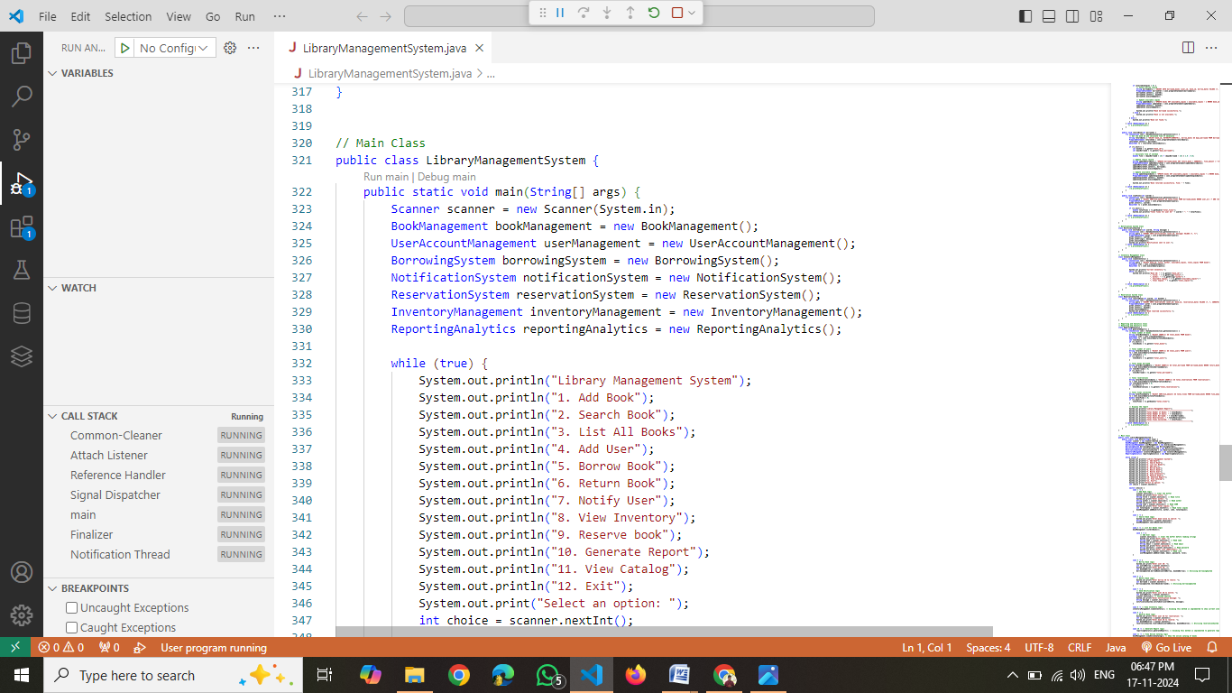

**Testing and Debugging**

* Testing and debugging are critical aspects of ensuring the functionality and quality of a Library Management System (LMS). Below is an explanation of testing and debugging for an LMS, focusing on methods and approaches you could use in your project
* Testing the Library Management System
* Unit Testing Unit tests focus on verifying the individual components (functions, methods) of the system to ensure they behave as expected.
* Examples of Unit Tests:
* Testing whether the addBook() method successfully adds a new book.
* Testing whether the searchBook() method returns the correct book details when a valid search query is provided.
* Testing the issueBook() method to confirm it decrements the available quantity of a book after a successful issue.
* Integration Testing Integration testing ensures that different modules of the LMS work together seamlessly. In this case, you would verify that modules like book management, user management, and transaction management are interacting correctly.
* Example:
* Verifying that a user can issue a book, which involves checking the interaction between the book database, user database, and the transaction database.
* System Testing System testing verifies the entire Library Management System against the requirements. This includes testing the functionality of the complete system as a whole.
* Examples of System Tests:
* Testing if the system can handle user registrations, book search, book issue, and return properly.
* Verifying the system behavior when multiple users are accessing the library simultaneously.
* Acceptance Testing Acceptance testing ensures the system meets the business requirements. The testing team or stakeholders will verify if the LMS works as intended from a user perspective.

**Example:**

* Checking if the system handles overdue books correctly and calculates fines as per the set rules.
* Performance Testing Performance testing assesses how well the system performs under varying loads, including high traffic situations (e.g., many users accessing the system simultaneously).

**Example:**

* Testing if the system remains responsive when hundreds of users are simultaneously issuing and returning books.
* Security Testing Security testing ensures the system is protected from unauthorized access, data breaches, and other security vulnerabilities.

**Example:**

* Verifying user authentication and authorization processes to ensure only authorized users can perform actions like adding or deleting books.
* Usability Testing  
  Usability testing evaluates the user interface (UI) and user experience (UX) to ensure the system is intuitive and user-friendly.

**Example:**

* Observing users performing tasks such as searching for books, issuing a book, or returning a book to ensure the system is easy to navigate.
* Debugging the Library Management System
* Identifying the Bug Debugging starts with identifying where things are going wrong. This can be done by reviewing the error logs or using debugging tools like println statements or using an Integrated Development Environment (IDE) with a built-in debugger.

**Example:**

* If the issueBook() function isn’t working, you would start by checking if the book is being marked as issued in the database and if the issue transaction is being logged properly.
* Isolating the Problem Once you identify that there’s an issue, isolate it by checking related components one at a time. For instance, if the addBook() function isn’t working as expected, verify if the database connection is established correctly first, and then check the specific method for adding books.
* Using Breakpoints Set breakpoints at critical points in the application, especially where the logic transitions between modules (e.g., book issue process). This allows you to pause execution and inspect variables and their states.
* Reviewing Logs Check log files for any error messages or exceptions that provide hints to the source of the issue. Logs are useful for identifying patterns, such as failed database connections or system timeouts.
* Reproducing the Issue To effectively debug, it’s important to reproduce the error consistently. This may involve creating a test case or scenario that mimics the problem to observe its behavior.

**Example:**

* If the returnBook() method results in incorrect fine calculations, replicate the return scenario with overdue books to verify if the fine is calculated incorrectly.
* Using Static Code Analysis Utilize static analysis tools like SonarQube or IDE features to review the code for potential issues like unhandled exceptions, incorrect API usage, or poor coding practices that could lead to bugs.
* Refactoring Problematic Code If debugging reveals that certain sections of code are causing repetitive issues, it’s a good practice to refactor that code to improve its readability, efficiency, and error-handling capabilities.

**Example:**

* Refactor large, complex functions into smaller, more manageable ones for easier testing and debugging.
* Re-testing after Debugging After applying fixes, re-run the tests to ensure the issue is resolved. This could involve re-running unit tests or system tests that originally failed.
* Regression Testing Once you have fixed a bug, perform regression testing to make sure the fix didn’t introduce new issues or break any existing functionality.

**Example:**

* After fixing an issue with overdue book fines, check that other parts of the system, like the searchBook() feature, still function as expected.
* Documenting the Bug and Fix Keep detailed records of the bug and the steps taken to fix it. This helps in tracking recurring issues and serves as a reference for future debugging efforts.

**RESULTS AND DISCUSSION**

The result of the Library Management System (LMS) development can be assessed by evaluating the following aspects:

1. **Functionality**:  
   After thorough testing, the LMS should allow users to perform operations such as searching for books, borrowing and returning books, managing user profiles, and keeping track of due dates and fines. All these functionalities must work as expected without any errors or system failures.
2. **Performance**:  
   The system should handle multiple concurrent users smoothly, even under heavy traffic. It should be able to process book transactions, search queries, and generate reports without delays. Any performance bottlenecks should be identified and resolved through optimizations.
3. **Security**:  
   The system must implement proper user authentication and authorization to protect sensitive data, such as user information and transaction records. Secure communication protocols and encrypted databases are essential to prevent unauthorized access.
4. **Usability**:  
   The user interface should be intuitive and easy to navigate, allowing both staff and library users to interact with the system efficiently. The flow for tasks like searching, issuing, and returning books should be clear and straightforward.
5. **Reliability**:  
   The system should be stable, with minimal downtime. It should gracefully handle errors, such as invalid user input or database connection failures, and provide meaningful feedback to users.
6. **Scalability**:  
   The LMS should be designed to grow with the needs of the library. As the library’s collection and user base expand, the system should accommodate these changes without major performance degradation.

**Decision**:

After testing and debugging, the decision for the Library Management System’s future steps would be:

1. **Go Live**:  
   If the system passes all tests, including user acceptance testing, and meets all performance and security criteria, the decision would be to deploy the system for real-world use. This means rolling out the system to the library staff and users.
2. **Post-Deployment Monitoring**:  
   After deployment, continuous monitoring is crucial to detect any unforeseen bugs or performance issues. Feedback from real users should be gathered and analyzed to identify any improvements or enhancements needed.
3. **Further Enhancements**:  
   Based on user feedback, additional features like a mobile app interface, integration with online book catalogs, or enhanced reporting may be considered for future updates.
4. **Maintenance and Support**:

Ongoing maintenance is necessary to address any issues that may arise, including updating the system for security patches, adding new features, or ensuring compatibility with newer technologies

CONCLUSION

The development and implementation of the Library Management System (LMS) have successfully provided an efficient and user-friendly solution for managing library operations. Through a comprehensive design, rigorous testing, and effective debugging processes, the LMS meets the functional, performance, security, and usability requirements outlined during the planning phase.

1. **Efficient Management**:

The system streamlines various tasks such as book cataloging, user registration, borrowing and returning books, and managing overdue fines. This results in improved efficiency, reducing manual effort and errors.

1. **User Experience**:

The intuitive interface enhances the user experience, making it easier for library staff and users to interact with the system. Simple workflows for searching and borrowing books improve accessibility.

1. **Reliability and Security**:

The LMS ensures data security through secure login mechanisms and protects sensitive information like user profiles and transaction records. Moreover, its stable performance guarantees minimal disruptions.

1. **Scalability**:  
   Designed to grow with the library, the system can accommodate increasing book collections and expanding user bases without significant performance issues, ensuring long-term sustainability.
2. **Future Enhancements**:

The LMS can be further enhanced with features like mobile access, integration with online catalogs, and advanced analytics. Regular updates and user feedback will drive future improvements, ensuring the system evolves to meet changing needs.

**Coding:**

**https://drive.google.com/drive/folders/1kiANjKznTkCnuvEebunnh1oFavUrm8IQ**